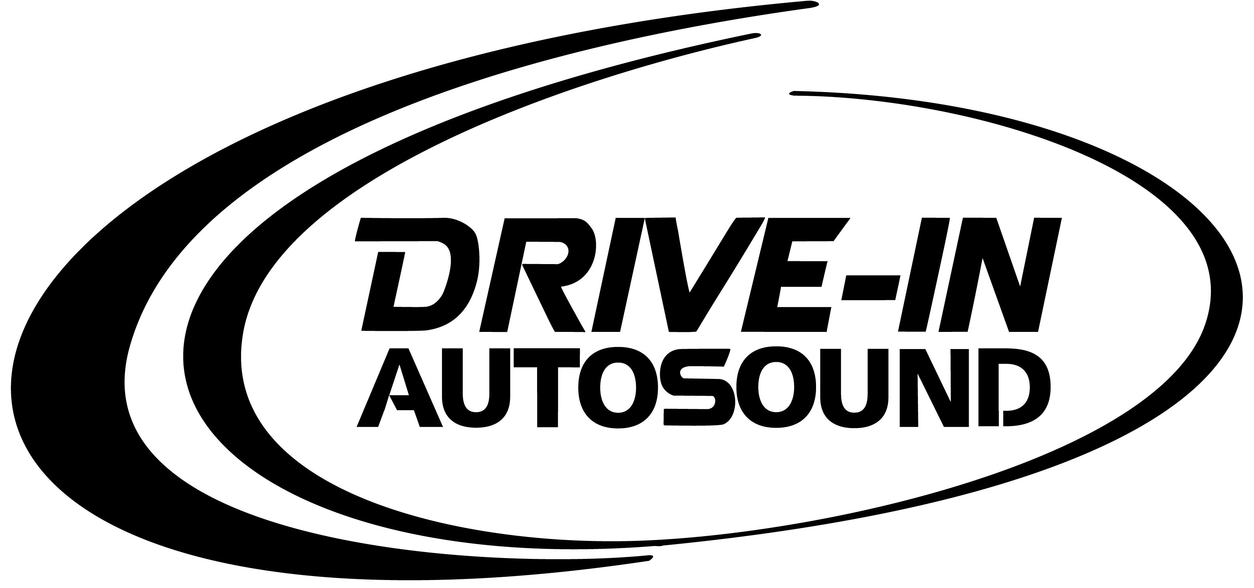

We are pleased to have a new payday convenience – Direct Deposit. Now your paycheck is automatically deposited in your checking or savings account on payday. And you don’t have to change your present banking.
Direct Deposit will help you in many ways.
- It saves trips to your financial institution.
- It saves time in depositing checks – no long payday lines to wait in.
- It eliminates the possibility of lost, stolen or forged checks.
- Your money is deposited faster – reduces the possibility of overdrafts.
- It means you get your money deposited to your account even if you’re on vacation or away from the office on business or illness.
Here’s how Direct Deposit works:
On payday you will receive an earnings statement showing gross salary, taxes, other deductions, and net pay. Your money will already have been deposited in your account. The amount of the deposit will appear on your bank statement. We believe you will like the added convenience of having your net pay automatically deposited for you. Direct Deposit is safe, convenient and easy. Complete the attached authorization form and return it to the Payroll Department.
The Authorization Form, which is provided below, gives your company and your financial institution authority to deposit your pay to your account. Simply complete the form in order to take advantage of Direct Deposit.
All you need to do is:
1. Mark the box before the type of account to indicate whether your pay will be deposited in your checking or savings account.
2. Fill in your name, financial institution name and location, and date.
3. Attach a voided check for verification of all financial institution information. Please fill in your account number and financial information in the space provided below.
NOTE: Be sure to sign the form!
EMPLOYEE’S AUTHORIZATION Please fill out clearly and return to the Payroll Department

STAPLE VOIDED CHECK HERE

AUTHORIZATION FOR DIRECT DEPOSIT
I authorize Drive In Autosound to initiate electronic credit entries, and if necessary, debit entries and adjustment for any credit entries in error to my:
___Checking account ___Savings account
each pay period. I acknowledge that the origination of ACH transactions to my account must comply with the provisions of U.S. law. This authority will remain in effect until I have cancelled it in writing.

Financial Institution Name (PRINT)
Financial Institution Routing/Transit Number
Account Number at Financial Institution
Financial Institution City and State
Employee Signature Empl No. Date
Please keep a copy of the authorization for your records

